**Evidence for Project Unit**

Rachael Ellen E20

**P. 1 Github Contributors page**

Castle Finder GitHub Repo. Contributions were made on Develop branch as work is still in progress and not ready to commit to master branch. Showing commits below.

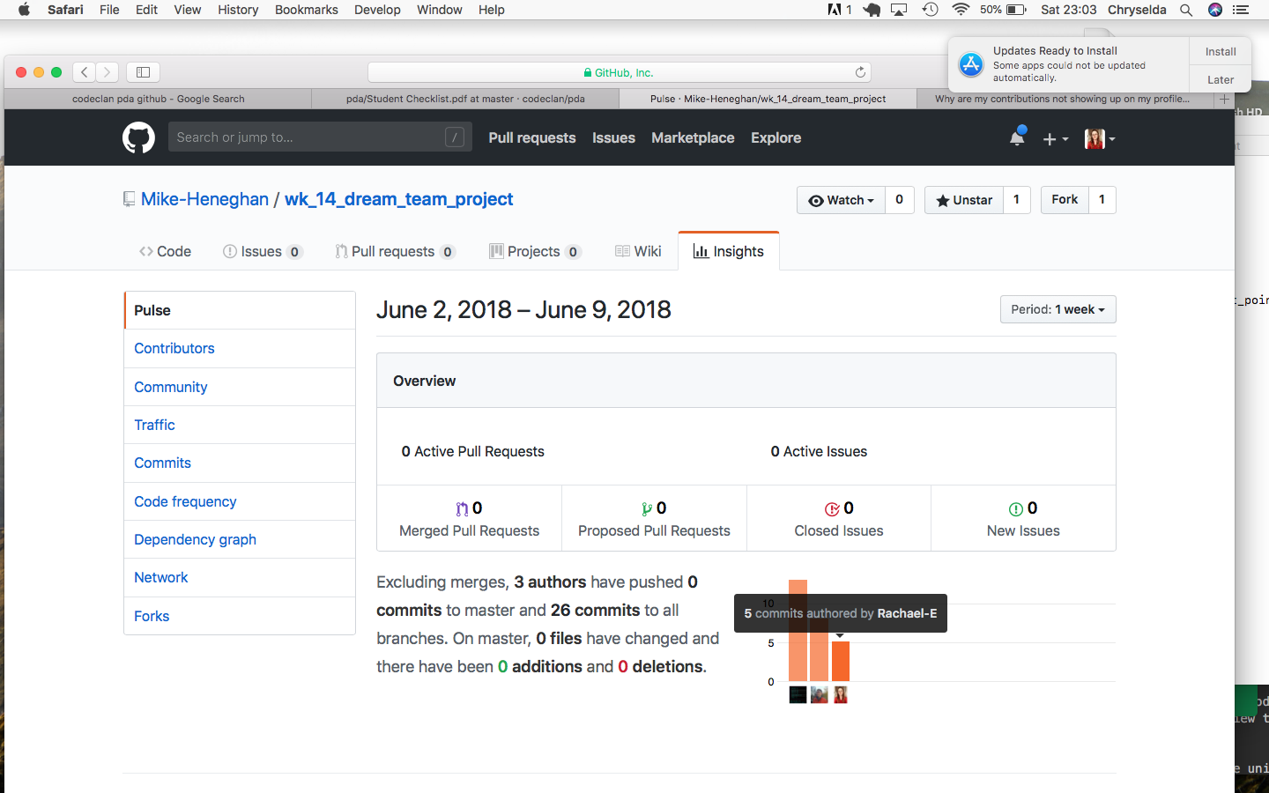

**P. 2 Project Brief**

Project brief for Group Project (Castle Finder)

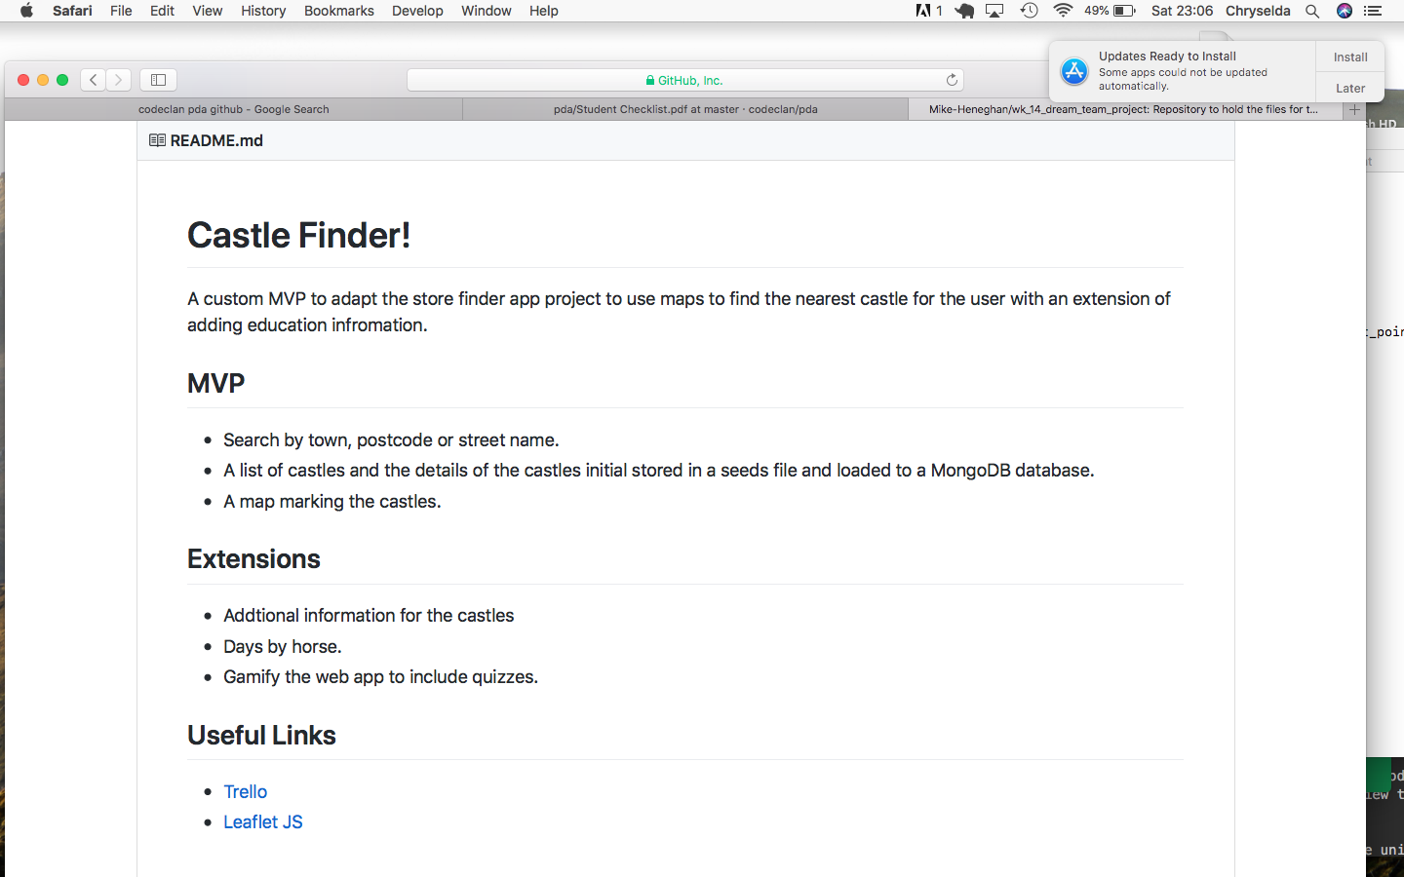

**P. 3 Use of Trello**

Planning on Trello for Group Project (Castle Finder)

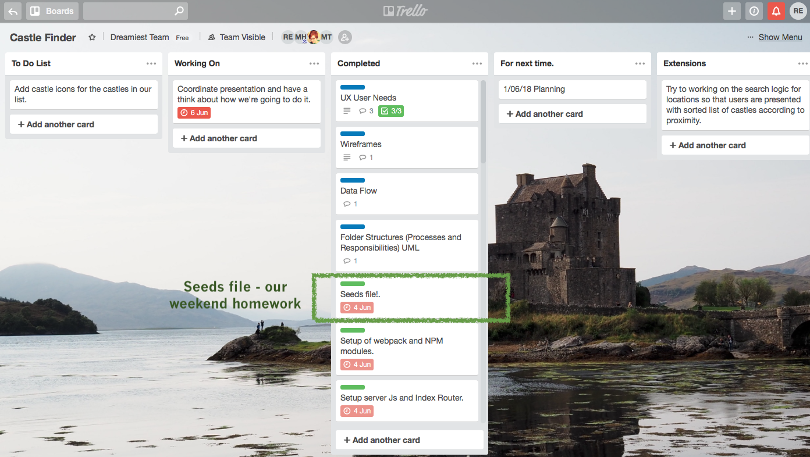

**P. 4 Acceptance Criteria**

Evidence for unit

**P. 5 User sitemap**

User sitemap for Ruby Individual Project (Pet shop)

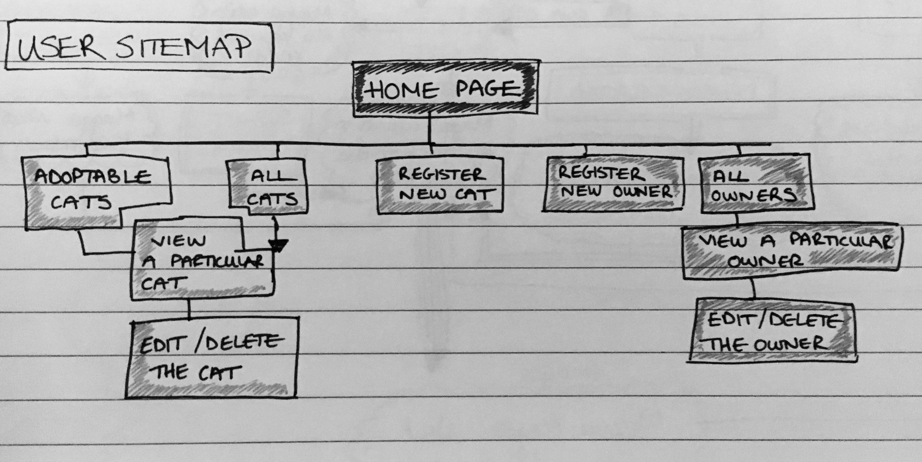

**P. 6 Wireframes designs**

Wireframe for Ruby Individual Project (pet shop)

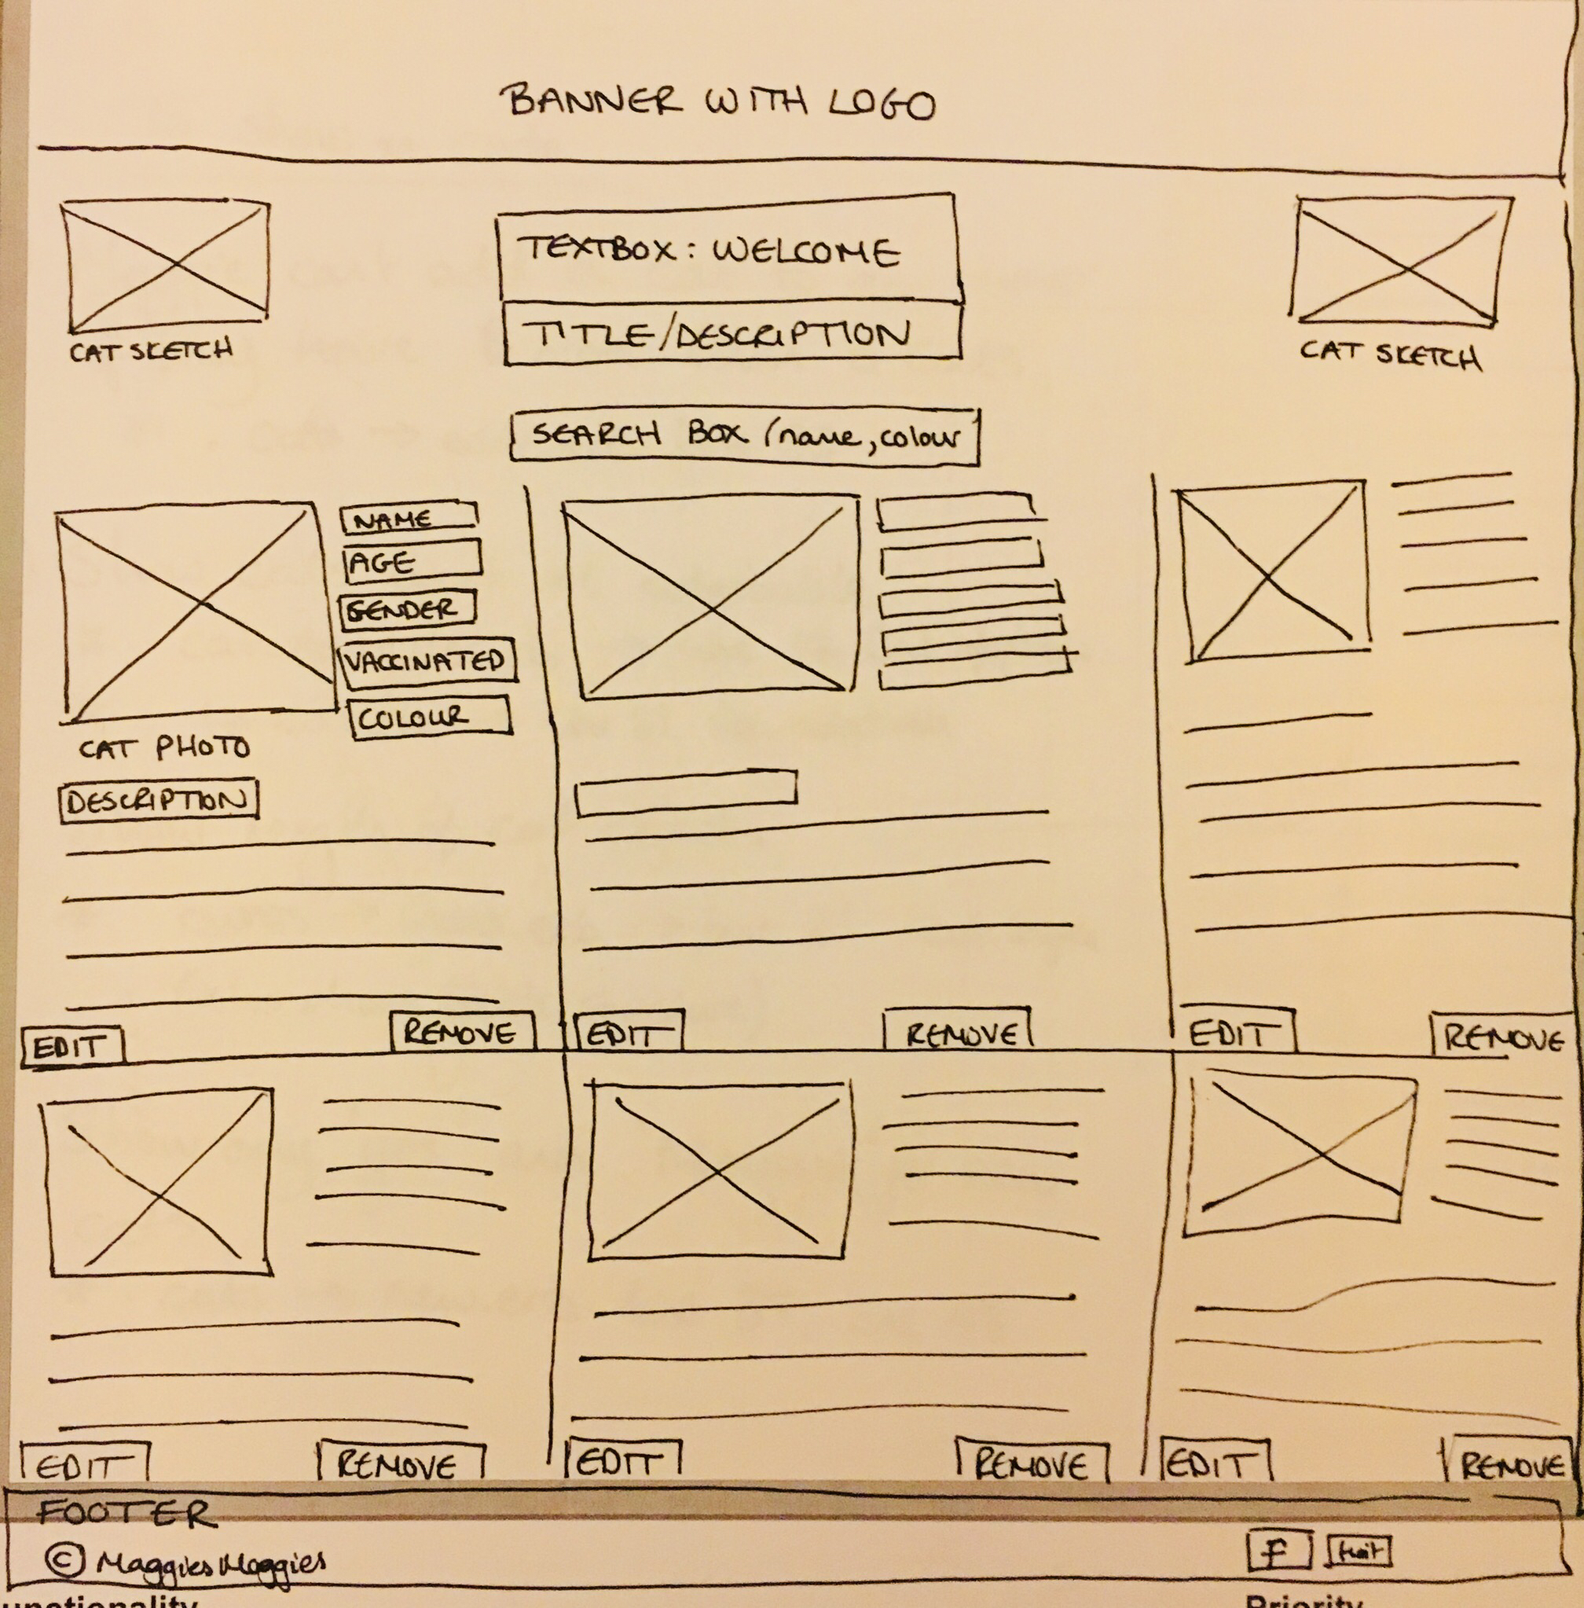

Wireframe for Android/Java Individual Project (GeoTracker)

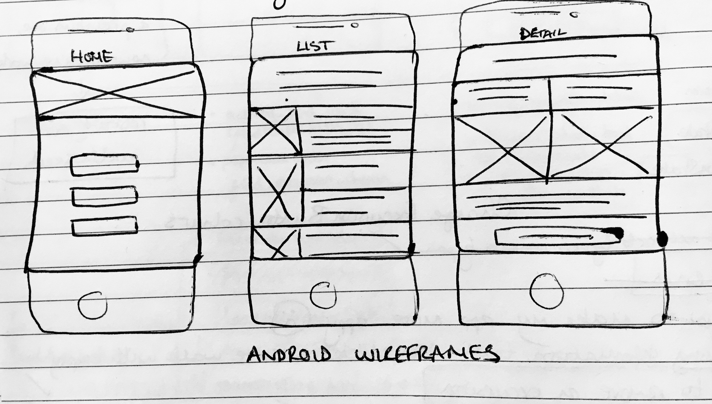

**P. 7 System interactions diagrams**

|  |  |
| --- | --- |
| Evidence for unit | Evidence for unit |

**P. 8 Two Object Diagrams**

Evidence for unit

Evidence for unit

Object diagrams?

**P. 9 Choice of two algorithms (find the algorithms on a program you might have written, show the code you have used. )**

**On this example please take a screenshot and write what it is doing and why you decided to use it.**

**P. 10 Example of Pseudocode**

Pseudocode in Android/Java project

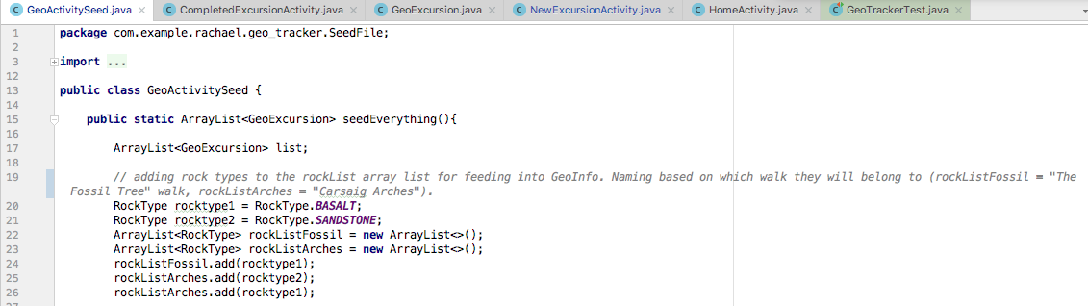

**P. 11 Github link to one of your projects**

**https://github.com/Rachael-E/cc_w5_cat_shelter**

**P. 12 Screenshot of your planning and the different stages of development to show changes.**

Evidence for unit

Evidence for unit

**P. 13 User input**

User can go to home page of app, and click ‘add your own excursion’. This opens a new app page where information can be entered. This can then be saved, and when back on the homepage, can click on ‘Find an Excursion’, which will then display the summary of the added entry, and then the full details when clicked.

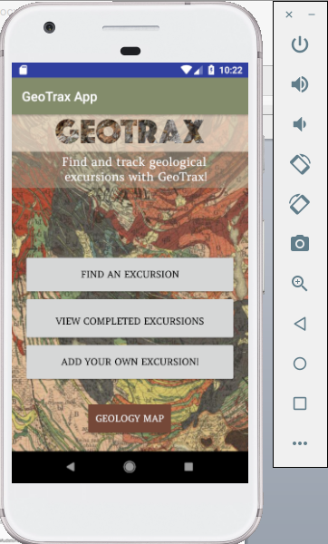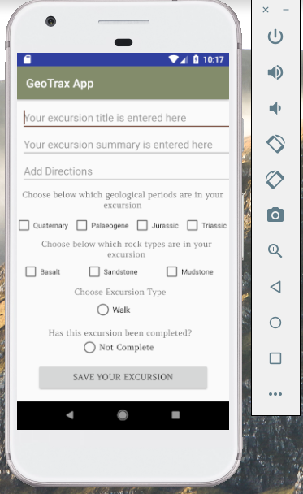

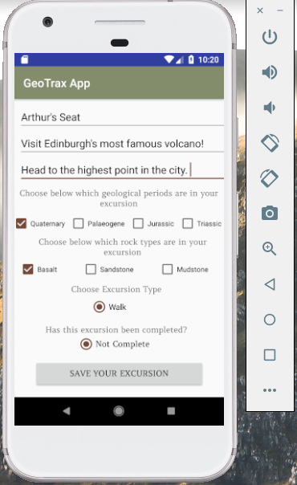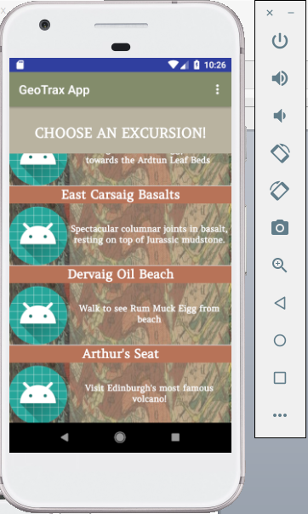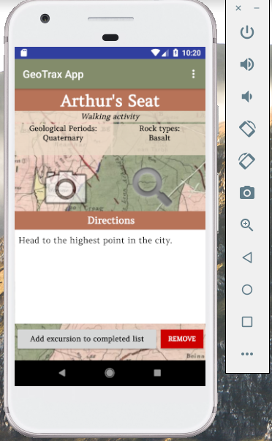

**P. 14 Interaction with data persistence**

**Make sure you show the input being added.**

Evidence for unit

ISN’T THIS JUST THE SAME AS P13???

**P. 15 User output result**

Evidence for unit

ISN’T THIS THE SAME AS P13 AND P14?

**P. 16 Bug tracking report showing the errors diagnosed and corrected.**

Evidence for unit

**P. 17 Testing your program**

**Show the test code, the test not passing.....and then the test fixed.**

Evidence for unit